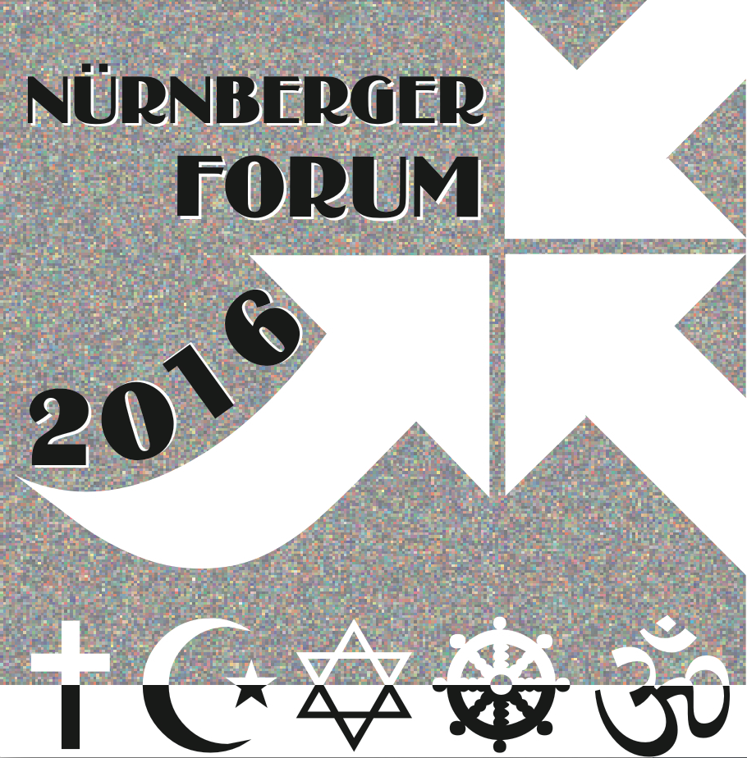
FRIEDRICH-ALEXANDER
UNIVERSITÄT
ERLANGEN-NÜRNBERG
PHILOSOPHISCHE FAKULTÄT
UND FACHBEREICH THEOLOGIE

Application for Financial Support
for participating in the
Young Researchers’ Workshop
within the International Conference
“Public Theology – Religion – Education. Interreligious Perspectives”
(12th Nuremberg Forum, 3 to 6 October 2016, in Nuremberg, Germany)
Please note:
By applying for financial support you confirm that you do not get financial support from any other institution.
If you are granted financial support, you will be expected to pay for all the costs first and after the conference submit the receipts, travel tickets, etc. for reimbursement.

Name:

Date of birth:

Address:

Institutional affiliation:

Email:

Expected estimated travel costs:

Bank account details
IBAN:
BIC:

